📊 Data Cleaning & Visualization Project Report
1. Introduction
The objective of this project is to clean a raw dataset and extract meaningful insights using data analysis and visualization techniques. Raw data often contains missing values, inconsistencies, and noise, which must be handled before analysis.

2. Dataset Description
The dataset used in this project contains student performance data, including:
- Name of students
- Marks in Math, Science, and English
- Attendance percentage
The dataset initially contained missing values and inconsistencies.
Output :
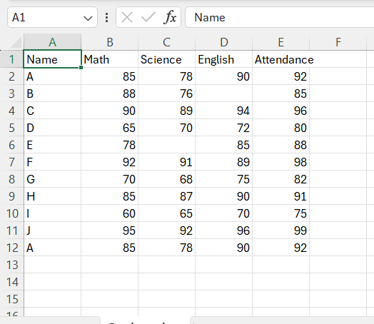

3. Data Cleaning Process
The following steps were performed to clean the dataset:
3.1 Handling Missing Values
Missing values were replaced using the mean of the respective columns to maintain data consistency.
3.2 Removing Duplicates
Duplicate records were identified and removed to ensure accuracy.
3.3 Handling Outliers
Outliers were treated using a clipping method to limit extreme values within a defined range.
Output :
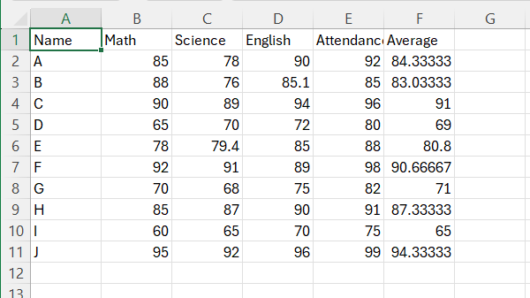

4. Tools and Technologies Used
- Python
- Pandas (for data manipulation)
- Matplotlib (for plotting graphs)
- Seaborn (for advanced visualization)
- Streamlit (for dashboard creation)

5. Data Visualization
Various visualizations were created to understand the dataset:
5.1 Bar Chart – Average Scores
This chart shows the average marks across subjects.
Output :
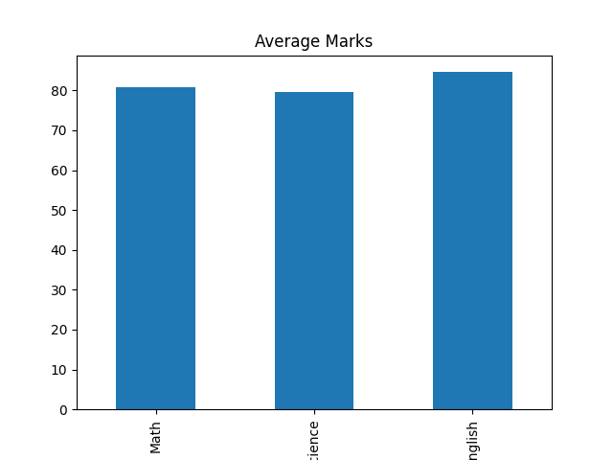
5.2 Line Chart – Performance Trend
This graph represents the trend of student performance.

Output :
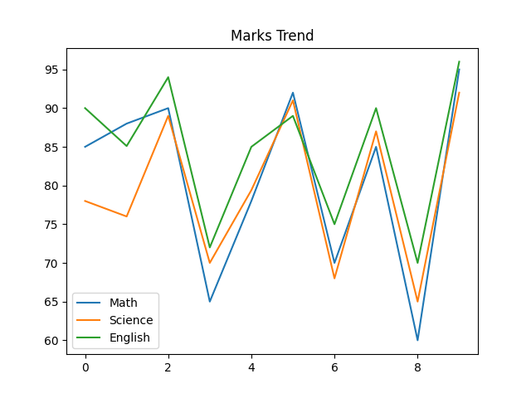
5.3 Heatmap – Correlation Analysis
The heatmap shows relationships between variables like marks and attendance.

Output :
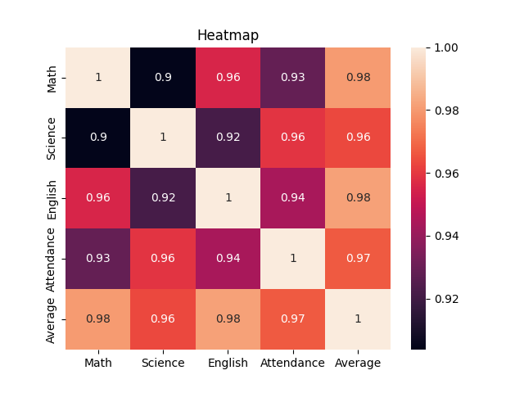

6. Key Insights
- Students with higher attendance tend to score better
- Math has the highest average score among subjects
- Data cleaning significantly improved analysis accuracy

7. Conclusion
This project demonstrates the importance of data preprocessing and visualization. Clean data helps in generating meaningful insights, which can support better decision-making.

8. Future Enhancements
- Build an interactive dashboard using Streamlit
- Use larger real-world datasets
- Apply machine learning models for prediction

9. References
- Python Documentation
- Pandas Library
- Matplotlib & Seaborn Documentation

